Anatomy of a Program in Memory
Memory management is the heart of operating systems; it is crucial for both programming and system administration. In the next few posts I’ll cover memory with an eye towards practical aspects, but without shying away from internals. While the concepts are generic, examples are mostly from Linux and Windows on 32-bit x86. This first post describes how programs are laid out in memory.
内存管理是操作系统的核心；它对程序员和系统管理员都至关重要。在下面的部分将着眼实际的内存，但又不会掩盖实现。概念是通用的，部分是来自x86的32位linux和windows。首先讲解程序在内存中的布局。
Each process in a multi-tasking OS runs in its own memory sandbox. This sandbox is the virtual address space, which in 32-bit mode is always a 4GB block of memory addresses. These virtual addresses are mapped to physical memory by page tables, which are maintained by the operating system kernel and consulted by the processor. Each process has its own set of page tables, but there is a catch. Once virtual addresses are enabled, they apply to all software running in the machine, including the kernel itself. Thus a portion of the virtual address space must be reserved to the kernel:
在多任务操作系统中每个进程运行在自己的内存沙箱当中。这个沙箱使用的虚拟内存空间，使用32位模式，总共4bg的内存地址。这个虚拟地址通过页表被映射到物理内存，这被操作系统内核和处理器进行管理。每个进程有自己的页表，但是这里有一个陷阱。一旦虚拟地址可用，他们将被应用到所有运行在机器当中的软件。包括内核。因此虚拟地址空间的一部分被保留给内核。
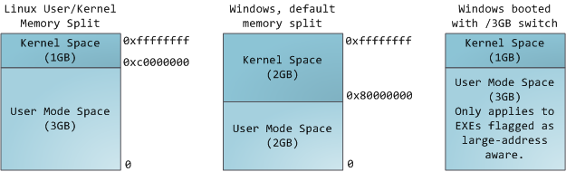
This does not mean the kernel uses that much physical memory, only that it has that portion of address space available to map whatever physical memory it wishes. Kernel space is flagged in the page tables as exclusive to privileged code (ring 2 or lower), hence a page fault is triggered if user-mode programs try to touch it. In Linux, kernel space is constantly present and maps the same physical memory in all processes. Kernel code and data are always addressable, ready to handle interrupts or system calls at any time. By contrast, the mapping for the user-mode portion of the address space changes whenever a process switch happens:
这不意味着内核使用那么多物理内存，只有部分地址空间可用映射到物理内存。内核空间在页表当中被标记为可执行特权代码（ring 2或者更低），此后如果一个用户空间爱你程序尝试接触它，将触发一个页错误。在linux当中，内核空间是不可变的并且在所有进程当中映射同样的物理内存，内核代码和数据总是可以寻址的，准备捕获中断和系统调用在任何时候。相反的，用户空间地址的部分映射会随时改变。
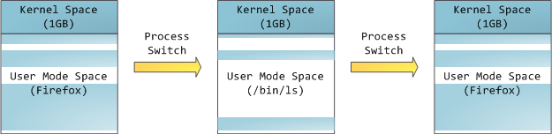
Blue regions represent virtual addresses that are mapped to physical memory, whereas white regions are unmapped. In the example above, Firefox has used far more of its virtual address space due to its legendary memory hunger. The distinct bands in the address space correspond to memory segments like the heap, stack, and so on. Keep in mind these segments are simply a range of memory addresses and have nothing to do with Intel-style segments. Anyway, here is the standard segment layout in a Linux process:
蓝色区域表示了虚拟地址被映射到物理内存，白色区域表示没有映射的。上面的例子当中，Firefox使用更多的虚拟地址空间因为其传奇的内存消耗。在地址空间不同的区域被内存段划分，像堆和栈，等等。记住这些段只是简单的内存范围并不是任何与intel风格的段有关。总之，这里是标准的Linux进程的段布局。
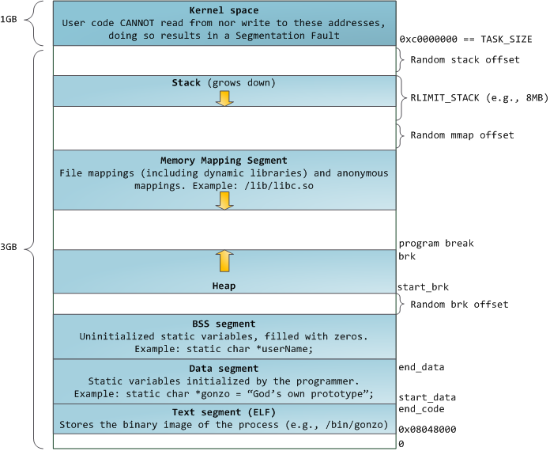
When computing was happy and safe and cuddly, the starting virtual addresses for the segments shown above were exactly the same for nearly every process in a machine. This made it easy to exploit security vulnerabilities remotely. An exploit often needs to reference absolute memory locations: an address on the stack, the address for a library function, etc. Remote attackers must choose this location blindly, counting on the fact that address spaces are all the same. When they are, people get pwned. Thus address space randomization has become popular. Linux randomizes the stack, memory mapping segment, and heap by adding offsets to their starting addresses. Unfortunately the 32-bit address space is pretty tight, leaving little room for randomization and hampering its effectiveness.
当计算正常安全的的运行时，段的虚拟地址在所有进程当中都如上所示。这使得非常容易远程溢出。一个溢出经常需要引用绝对内存定位： 在栈上的一个地址，一个库函数的地址等等。远程攻击者必须选择这些定位，计算实际的地址。........因此随机地址空间成为流行。linux随机生成，栈，内存映射和堆通过在他们的开始地址上添加偏移。不幸的是32位地址空间十分的狭窄，只留有很少的空间用来随机和防止其奏效。
The topmost segment in the process address space is the stack, which stores local variables and function parameters in most programming languages. Calling a method or function pushes a new stack frame onto the stack. The stack frame is destroyed when the function returns. This simple design, possible because the data obeys strict LIFO order, means that no complex data structure is needed to track stack contents - a simple pointer to the top of the stack will do. Pushing and popping are thus very fast and deterministic. Also, the constant reuse of stack regions tends to keep active stack memory in the cpu caches, speeding up access. Each thread in a process gets its own stack.
在进程地址空间当中最顶端的是栈，这里存储了大部分变成语言的本地变量和函数参数。呼叫一个方法或者函数，将新的栈贞压入栈中。当函数返回时，栈贞销毁。这个简单的实际，是因为数据严格遵守LIFO顺序。意味着不需要复杂的数据结构来跟踪栈的内容－仅需要一个指向栈顶的指针。因此压栈和出栈十分的快。同样，长期使用的内存区域会记录在cpu缓冲当中，加速访问。进程中的每个线程有自己的堆栈。
It is possible to exhaust the area mapping the stack by pushing more data than it can fit. This triggers a page fault that is handled in Linux by expand_stack(), which in turn calls acct_stack_growth() to check whether it’s appropriate to grow the stack. If the stack size is below RLIMIT_STACK (usually 8MB), then normally the stack grows and the program continues merrily, unaware of what just happened. This is the normal mechanism whereby stack size adjusts to demand. However, if the maximum stack size has been reached, we have a stack overflow and the program receives a Segmentation Fault. While the mapped stack area expands to meet demand, it does not shrink back when the stack gets smaller. Like the federal budget, it only expands.
通过压入更多的数据可以耗尽映射的堆栈。这将在expand_stack中触发一个页错误，它将调用acct_stack_growth来检查是否需要加大栈。如果栈小于RLIMIT_STACK(通常是8MB），则栈会增长，不用关系发生了什么。这是通常栈大小调整。然而如果达到栈的最大尺寸，将会出现栈溢出并产生一个段错误给程序。当映射过的栈区域扩展到需求，它将不会为了栈空间减少而缩小。
Dynamic stack growth is the only situation in which access to an unmapped memory region, shown in white above, might be valid. Any other access to unmapped memory triggers a page fault that results in a Segmentation Fault. Some mapped areas are read-only, hence write attempts to these areas also lead to segfaults.
动态的栈增长是仅有的访问未映射内存区域的情况，如上白色区域。任何其他访问未映射内存将出发一个页错误导致段错误。一些映射区域是只读的，因此写该区域会导致段错误。
Below the stack, we have the memory mapping segment. Here the kernel maps contents of files directly to memory. Any application can ask for such a mapping via the Linux mmap() system call (implementation) or CreateFileMapping() / MapViewOfFile() in Windows. Memory mapping is a convenient and high-performance way to do file I/O, so it is used for loading dynamic libraries. It is also possible to create an anonymous memory mapping that does not correspond to any files, being used instead for program data. In Linux, if you request a large block of memory via malloc(), the C library will create such an anonymous mapping instead of using heap memory. ‘Large’ means larger than MMAP_THRESHOLD bytes, 128 kB by default and adjustable via mallopt().
在栈的下面，我们有内存映射段。在这里内核直接映射文件内容到内存。任何程序可以通过Linux的mmap()系统调用访问这样一个映射。内存映射是一种方便高性能的文件I/O方式。它被用来加在动态连接库。也可以创建一个不对应任何文件的匿名内存映射。用来代替程序数据。在Linux当中，如果你通过malloc请求一个较大的内存块，c库将创建一个匿名映射空间来代替使用堆内存。大内存块以为着大于MMAP_THRESHOLD指定的大小，默认大小是128kb。可通过mallopt()进行调整。
Speaking of the heap, it comes next in our plunge into address space. The heap provides runtime memory allocation, like the stack, meant for data that must outlive the function doing the allocation, unlike the stack. Most languages provide heap management to programs. Satisfying memory requests is thus a joint affair between the language runtime and the kernel. In C, the interface to heap allocation is malloc() and friends, whereas in a garbage-collected language like C# the interface is the new keyword.
说到堆，我们将关注下一块地址空间。同栈一样堆提供了运行时内存分配，与栈不一样的是数据存活在分配它的函数之外。到部分语言提供堆管理。满足内存请求是语言运行时和内核共同的事。在c中，堆分配的接口是malloc()。带有内存回收机制的语言如c#使用new关键字。
If there is enough space in the heap to satisfy a memory request, it can be handled by the language runtime without kernel involvement. Otherwise the heap is enlarged via the brk() system call (implementation) to make room for the requested block. Heap management is complex, requiring sophisticated algorithms that strive for speed and efficient memory usage in the face of our programs’ chaotic allocation patterns. The time needed to service a heap request can vary substantially. Real-time systems have special-purpose allocators to deal with this problem. Heaps also become fragmented, shown below:
如果在堆中有足够的空间来满足内存请求，这可以被语言运行时接手处理，不需要内核的参与。否则通过brk()系统调用多大堆。堆管理十分复杂，在我们混乱的内存分配模式的程序中需要复杂的算法来满足速度和效率。实时系统还有特殊的分配母体，用来处理浙西饿问题。堆同样变得分散，如下所示：
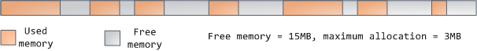
Finally, we get to the lowest segments of memory: BSS, data, and program text. Both BSS and data store contents for static (global) variables in C. The difference is that BSS stores the contents of uninitialized static variables, whose values are not set by the programmer in source code. The BSS memory area is anonymous: it does not map any file. If you say static int cntActiveUsers, the contents of cntActiveUsers live in the BSS.
最后，还有最下面的内存段：BSS, data 和 text。在c语言中BSS和data都存储的静态（全局）变量。不同的饿是，BSS存储的未初始化的静态变量，他们的值没有在程序源码中指定。BSS内存区域是匿名的：它不映射任何文件.如果定义 static int cnt ActiveUsers，则该变量存储在BSS中。
The data segment, on the other hand, holds the contents for static variables initialized in source code. This memory area is not anonymous. It maps the part of the program’s binary image that contains the initial static values given in source code. So if you say static int cntWorkerBees = 10, the contents of cntWorkerBees live in the data segment and start out as 10. Even though the data segment maps a file, it is a private memory mapping, which means that updates to memory are not reflected in the underlying file. This must be the case, otherwise assignments to global variables would change your on-disk binary image.
数据段，存放源码中初始化的静态变量。这段内存不是匿名的。它映射程序二进制文件包含初始化的静态变量部分。如static int cntWorkerBees = 10，cntWorkerBees将存放在数据段中，初始值为10。即使数据段映射一个文件，它是一个似有内存映射，以为改变其中的内容也不会更新对应文件。否则该赋值全局变量将改变磁盘上的二进制文件。
Inconceivable!
不可思议！
The data example in the diagram is trickier because it uses a pointer. In that case, the contents of pointer gonzo - a 4-byte memory address - live in the data segment. The actual string it points to does not, however. The string lives in the text segment, which is read-only and stores all of your code in addition to tidbits like string literals. The text segment also maps your binary file in memory, but writes to this area earn your program a Segmentation Fault. This helps prevent pointer bugs, though not as effectively as avoiding C in the first place. Here’s a diagram showing these segments and our example variables:
图中的数据示例有个陷阱，因为有一个指针。存放于数据段当中的指针gonzo是一个4字节内存地址。实际的字符串存在于text段中，它是只读的并却存储你所有的代码。文本段同样是二进制文件的内存映射，如果写入该区域，你的程序将得到段错误。这有助于防止指针错误，
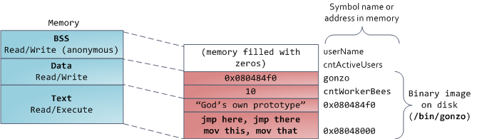
You can examine the memory areas in a Linux process by reading the file /proc/pid_of_process/maps. Keep in mind that a segment may contain many areas. For example, each memory mapped file normally has its own area in the mmap segment, and dynamic libraries have extra areas similar to BSS and data. The next post will clarify what ‘area’ really means. Also, sometimes people say “data segment” meaning all of data + bss + heap.
你可以通过/proc/[pid]/maps检查一个linux进程的内存区域。记住一个段可以包含很多区域。例如，在mmap段中每个内存映射文件通常有它自己的区域，并且动态链接库有类似于bss和data的额外区域。同样有时人们称数据段一位着所有data+bss+heap。
You can examine binary images using the nm and objdump commands to display symbols, their addresses, segments, and so on. Finally, the virtual address layout described above is the “flexible” layout in Linux, which has been the default for a few years. It assumes that we have a value for RLIMIT_STACK. When that’s not the case, Linux reverts back to the “classic” layout shown below:
你可以试用nm和objdump检查二进制文件的符号，他们的地址，段，等等。最终，在linux当中，如上的虚拟地址布局描述是灵活的。
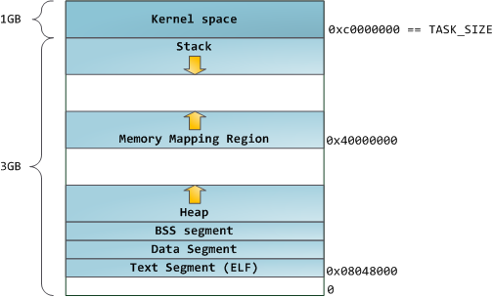
That’s it for virtual address space layout. The next post discusses how the kernel keeps track of these memory areas. Coming up we’ll look at memory mapping, how file reading and writing ties into all this and what memory usage figures mean.

